LAB 2 Tasks
Task 1:
#include <iostream>
using namespace std;

class DynamicMatrix
{
public:
int rows,columns;
int** matrix;
DynamicMatrix(int r, int c)
{
rows=r;
columns=c;
matrix = new int*[rows];
for (int i = 0; i < rows; i++)
{
matrix[i] = new int[columns];
for(int j=0; j<columns; j++)
matrix[i][j]=0;
}
}

void resize(int nr, int nc)
{
int** newMatrix = new int*[nr];
for(int i=0; i<nr; i++)
{
newMatrix[i]=new int[nc];
for(int j=0; j<nc; j++)
{
if(i<rows && j<columns)
newMatrix[i][j] = matrix[i][j];
else
{
cout << "Enter new value: ";
cin >> newMatrix[i][j];
}
}
}

for(int i=0; i<rows; i++)
{
delete[] matrix[i];
}
delete[] matrix;
matrix=newMatrix;
rows = nr;
columns = nc;
}

void transpose()
{
int** transpose = new int*[columns];
for(int i=0; i<columns; i++)
{
transpose[i] = new int[rows];
for(int j=0; j<rows; j++)
transpose[i][j]=matrix[j][i];
}
for (int i = 0; i < rows; i++)
delete[] matrix[i];
delete[] matrix;

int temp = rows;
rows = columns;
columns = temp;
matrix = transpose;
}

void printMatrix()
{
for(int i=0; i<rows; i++)
{
for(int j=0; j<columns; j++)
{
if((i+j)%2 != 0)
matrix[i][j]+=2;
cout << "Element " << j+1 << " : " << matrix[i][j] << endl;
}
}
}

~DynamicMatrix()
{
for(int i=0; i<rows; i++)
{
delete[] matrix[i];
}
delete[] matrix;
}
};

int main()
{
int r,c;
cout << "Enter number of rows: ";
cin >> r;
cout << "Enter number of columns: ";
cin >> c;
DynamicMatrix mat(r,c);
cout << "Enter new rows: ";
cin >> r;
cout << "Enter new columns: ";
cin >> c;
mat.resize(r,c);
mat.transpose();
mat.printMatrix();
}

OUTPUT:
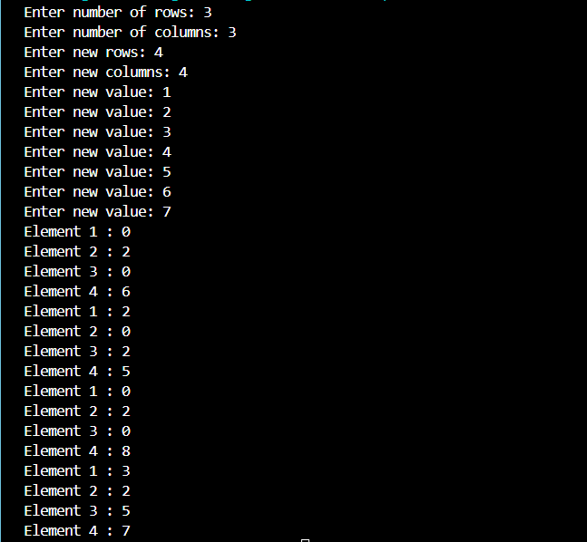

Task 2:
#include <iostream>
using namespace std;

int main()
{
int** university;
university=new int*[5];
for(int i=0; i<5; i++)
{
university[i]=new int[5];
cout << "Enter marks for Department " << i+1 << " :\n";
for(int j=0; j<5; j++)
{
cout << "Enter marks of subject " << j+1 << " : ";
cin >> university[i][j];
}
}

int max,min,avg,sum;
for(int i=0; i<5; i++)
{
sum=0;
max=university[i][0],min=university[i][0];
for(int j=0; j<5; j++)
{
if(university[i][j]>max)
max=university[i][j];
if(university[i][j]<min)
min=university[i][j];
sum+=university[i][j];
}
avg=sum/5;
cout << "Highest marks of department " << i+1 << " : " << max << endl;
cout << "Lowest marks of department " << i+1 << " : " << min << endl;
cout << "Average marks of department " << i+1 << " : " << avg << endl;
}
}

OUTPUT:
